Sort & Learn

Sort & Learn

Activity Overview
Students experience how AI learns patterns from training data by creating, testing, and improving sorting rules, connecting to how AI models learn and make predictions.
Learning Objective  Students understand how AI learns patterns from training data through hands-on sorting and rule creation. | Standards & Competencies  - 1b (Understand Mechanics)  - 2b (Examine AI outputs)  - CCSS.MATH.PRACTICE.MP7 Look for and make use of structure
Materials  - Object Cards (Sets A and B)  - Recording Sheets | Preparation  - Prepare object cards and recording sheets.

Launch (2-3 minutes)
Slide | Exploration Guide
 | Say: "How do computers learn to sort objects?”  Students share initial thoughts.
💡Teaching Tip: To help students engage in the activity, give students 30 seconds to think independently before sharing.

Play (11-17 minutes)
Slide | Exploration Guide
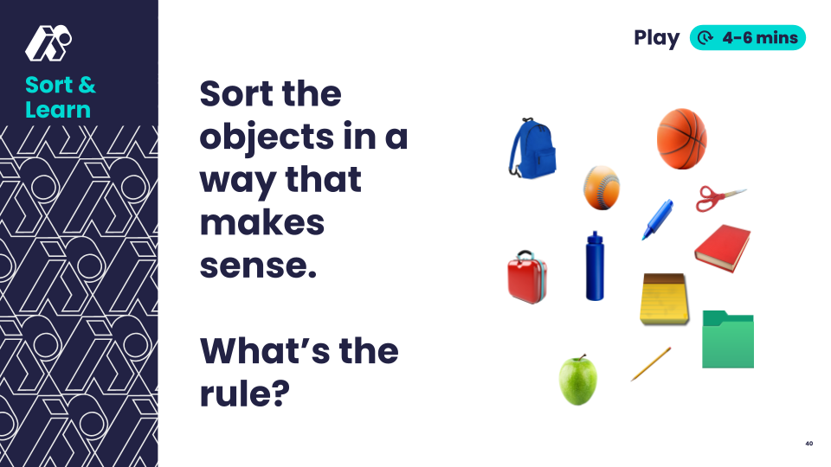 | Organize students into small groups. Distribute Set A object cards.  Say: "Your team's job is to create a sorting rule so clear that an AI could learn it!"  Task:  - Sort objects in a way that makes sense to the group.  - Record the sorting rule.  Distribute Set B object cards.  - Test the rule on Set B.  Look For:  - Groups organizing according to clear categories  - Clear and precise rules
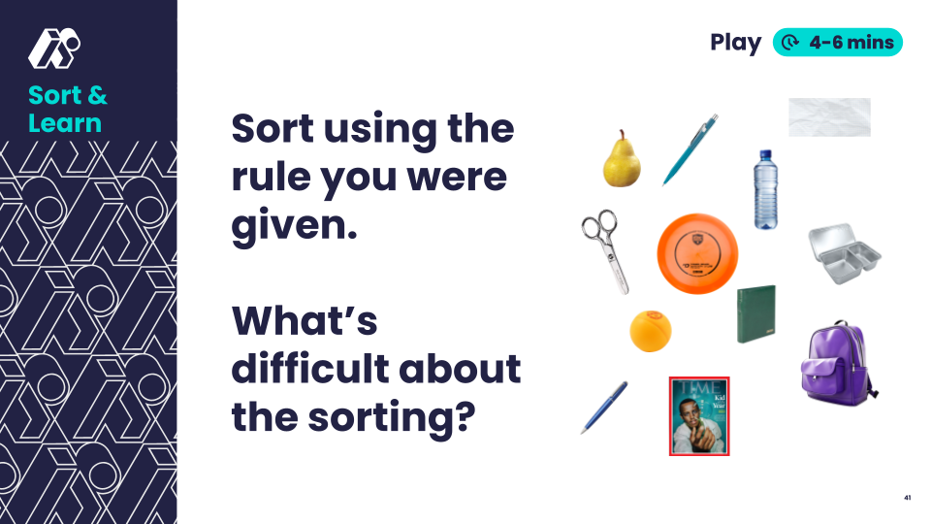 | Say: "Now you'll be the AI! Use only the written rules to sort these new objects."  Groups exchange rules and begin sorting Set B cards. Students note points of confusion and objects that are difficult to sort.  Look For:  - Logical rule interpretation  - Students identifying objects that are difficult to sort based on unclear attributes, e.g. does the Time magazine count as “red”?
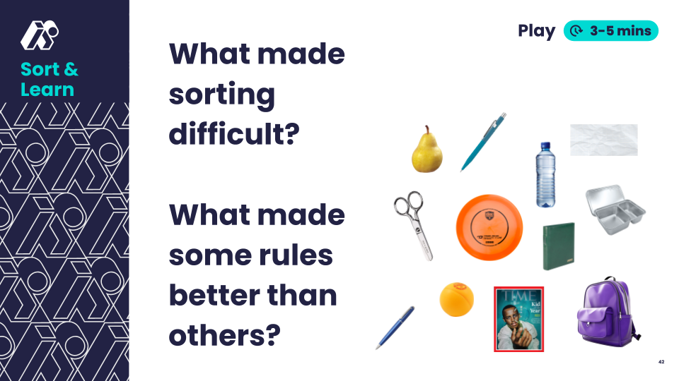 | Say: "Let's compare how different AIs (teams) sorted the same objects. What objects were difficult to sort? What made some rules work better than others?"  Look For:  - Students comparing and contrasting sorts, suggesting rule improvements  - Students identifying difficult to sort objects, e.g. does the Time magazine count as “red”?
💡Teaching Tip: Provide rule-writing sentence frame: “Group objects by _____.” Provide prompts to support discussion:
- "The rule needs..."
- "We could add..."
- "It would be clearer if..."

Land (2-4 minutes)
Slide | Exploration Guide
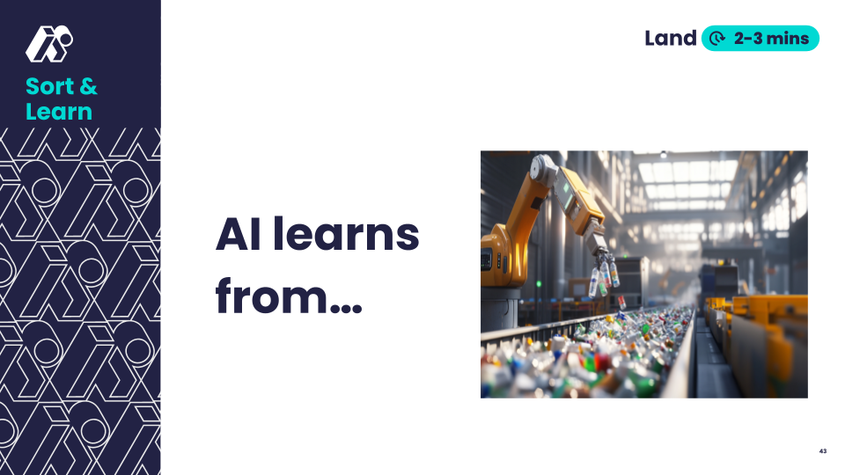 | Say: "Complete the sentence. ‘AI learns by…’"  Look For:  - AI learns from clear examples, like humans do  - More examples improve learning
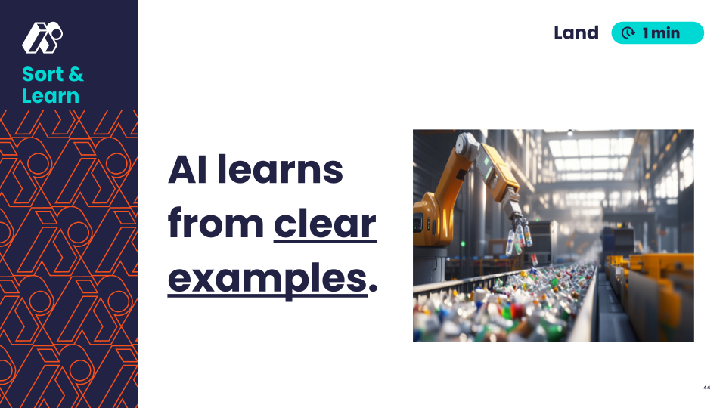 | Say: "AI learns from finding patterns in clear examples."
💡Teaching Tip: Give students the option to respond verbally, in writing, or with a drawing.

